**Journey Through The Bible**

**Joseph and Mary**

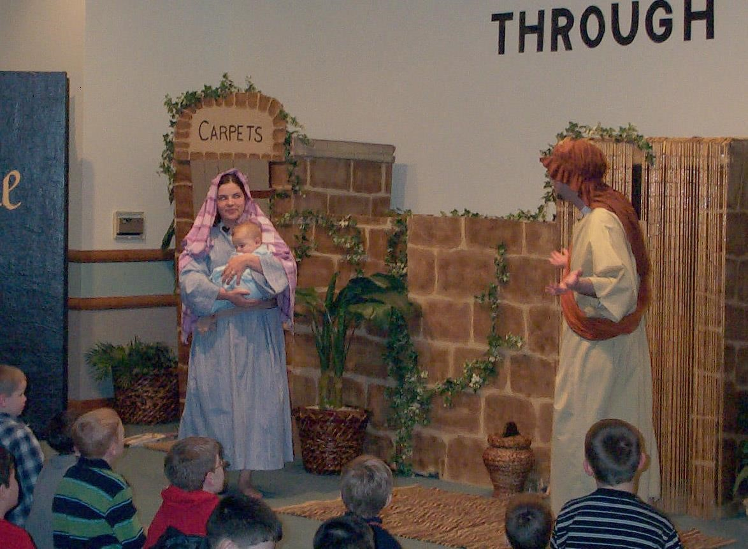

***Joseph:***

My name is Joseph and I am a member of the house of David. It is time for my family and me to be taxed. To do this, we must go to the little town known as Bethlehem.

***Mary:***

My name is Mary, and Joseph is my husband. I am expecting a baby and after we arrived at Bethlehem, I knew that it was time for me to give birth.

***Joseph:***

We searched to find a room in the inns, but they were all full. Finally one of the inn keepers told me there was a stable in the back that we could use.

***Mary:***

I delivered our baby Jesus and wrapped him in tight cloths and laid him in a manger.

***Joseph:***

Nearby there are shepherds in a field watching their sheep. Suddenly, an angel stood in front of them and told them that their Savior was just born in Bethlehem, and that he was Christ the Lord. The angels told them where to find us. Then a lot of other angels came and began to praise God and say, “Glory to God in the highest, and on earth, peace, and good will toward men.”

The shepherds were a bit scared, but after the angels went back up into heaver, they decided to go see the baby. They visited with us for a while and went away and told everyone what the angels had said and what they saw; the people marveled at what they said.

***Mary:***

I didn’t say much about the shepherds and what they said. I just thought about it and kept it in my heart.

The shepherds returned to their sheep praising God for his goodness.

***Joseph:***

If you would like to read our story in the Bible, open your Bible to the book of Luke.

***Mary:***

Now we would like to ask you some questions. (Prepare questions for the boys and girls.)

**Scripture reading:** Luke 2:1-20

**Memory Verse:**

Luke 1:37 - For with God nothing will be impossible.